System Requirements Statement (SRS)

Online driver hiring system

Doc. Ref. :

Version : 0.4

Status : Drafted

Created by : Kenji Tanaka

Date : 04-Dec-2012

1. Introduction 3

2. Functional Requirements 4

2.1 Customer Module 5

2.2 Driver Module 9

2.3 admin Module 14

2.4 Use Case Diagram..............................................................................................................................18

THIS DOCUMENT CONTAINS 20 NUMBERED PAGES

# Introduction

This document explains the system requirements and scope for developing Online driver hiring System.

Online driver hiring System is divided in three main parts: Customer part, Driver part and Admin part.

This document describes the system requirements of each part.

# Functional Requirements

The Account part of Online Driving Hiring System has three modules which are divided 34 processes described as below.

|  |  |  |
| --- | --- | --- |
| **No** | **BRS requirement ID** | **Description** |
| **2.1** | **Customer Module** | |
| **2.1.1** | **F1** | **Registration Process** |
| **2.1.2** | **F2** | **Login Process** |
| **2.1.3** | **F3** | **Forgot Password Process** |
| **2.1.4** | **F4** | **Change Password Process** |
| **2.1.5** | **F5** | **Update Account Process** |
| **2.1.6** | **F6** | **Book ride** |
| **2.1.7** | **F7** | **View Ride Details** |
| **2.1.8** | **F8** | **Cancel Ride** |
| **2.1.9** | **F9** | **Rate Driver** |
| **2.1.10** | **F10** | **Delete Account** |
| **2.2** | **Driver Module** | |
| **2.2.1** | **F11** | **Login Process** |
| **2.2.2** | **F12** | **Forgot Password Process** |
| **2.2.3** | **F13** | **~~Change Password Process~~** |
| **2.2.4** | **F14** | **Update Account Process** |
| **2.2.5** | **F15** | **View Upcoming Rides** |
| **2.2.6** | **F16** | **Confirm Ride** |
| **2.2.7** | **F17** | **Pay to Company** |
| **2.2.8** | **F18** | **View Ride History** |
| **2.2.9** | **F19** | **View Average Rating** |
| **2.2.10** | **F20** | **Deregister from System** |
| **2.3 Admin Module** | | |
| **2.3.1** | **F21** | **Login Process** |
| **2.3.2** | **F22** | **Forgot Password Process** |
| **2.3.3** | **F23** | **Change Password Process** |
| **2.3.4** | **F24** | **Update Account Process** |
| **2.3.5** | **F25** | **View all daily scheduled rides.** |
| **2.3.6** | **F26** | **View rides history of customer & driver** |
| **2.3.7** | **F27** | **View ratings & review of driver** |
| **2.3.8** | **F28** | **Add new city & routes details in the database** |
| **2.3.9** | **F29** | **Authenticate the new driver registration request** |
| **2.3.10** | **F30** | **Account Management** |
| **2.4 Message Acknowledgement Module** | | |
| **2.4.1** | **F31** | **Sends Messages of Acknowledgement** |
| **2.5 Use Case Diagrams** | | |
| **2.5.1** | **F32** | **Customer** |
| **2.5.2** | **F33** | **Driver** |
| **2.5.3** | **F34** | **Admin** |

## Customer Module

* Customer is the user of system who wants to hire driver.

### Registration Process

* Online Driver Hiring System compels to create the account before using it. So, system should provide the function which makes Customer creates new account.
* When Customer creates new account, the function demands information described as below.
* The User information

The User information consists of some items described as below.

1. First Name
2. Last Name
3. Email Address
4. Contact
5. Password
6. City
7. State
   * All items are compulsory demanded.
   * Email Address

* The Email Address should be unique.
  + Password
* The Password has constraints which makes the Password consists of more than or equal 8 and less than or equal 12 characteristics including characters described as below.

1. Numeric figure (at least one)
2. Capital alphabet (A-Z)(at least one)
3. Small alphabet (a-z)(at least one)
4. Special character (#, $, %, &, etc.) (at least one)

* The Password is masked by dummy characters. The re-entering Password is demanded.
* The Password must be encrypted in Online Driver Hiring System.
  + Address
* City should be selected from options.
* State should be selected from options.
* The Security Question information

The Security Question information is needed when customer lost their Password. This information consists of two items described as below.

1. Selected Question
2. Answer
   * All items are compulsory demanded.
   * Some questions which are difficult to answer for anyone else are prepared in advance.

E.g. which color do you like most?

* + A question should be selected from options by the Customer, and the Answer is registered by the Customer.
* All required registration information should be entered on single screen.

### Login Process

* Online Driver Hiring System always compels user authentication before using itself except when a new account is successfully created.
* The user authentication demands Email Address and Password. The Email Address and the Password should be checked in two ways.
  + First, The Email Address and the Password should be Entered and correct.
* If The Email Address and the Password are not equal to what the user has registered, the user authentication cannot be provided.
  + Second, the User Type linked to the Email Address should be "Customer".
* When the User Type is "Customer", then user can be placed on “Customer Home”.
* The “Customer Home” provides the some items described as below.

1. A trigger to logout.
2. A trigger to update Account.
3. A trigger to change Password.
4. A trigger to book Ride.
5. A trigger to ride Details.
6. A trigger to cancel Ride.
7. A trigger to make a Payment.
8. A trigger to view ride history.
9. A trigger to rate & review driver.
10. A trigger to delete account.

### Forgot Password Process

* When system user lost their Password, the recovery method should be provided by Online Driver Hiring system.

The recovery method is described as below.

* + First, system user enters their Email Address for Online Driver Hiring System.
  + Next, Online Driver Hiring demands the Answer which has been registered since when the Account was created.
  + Only when the Answer is correct, Customer get the old password by E-mail which also has been registered since when the Account was created.
* If the Answer is not correct, otherwise, the correct Answer is demanded for user again.
  + In that case, of course, he can contact company.

### Change Password Process

* When Customer wants to change their Password, the measure should be provided by Online Driver Hiring System.
* Therefore, Online Driver Hiring System should provide the function which is available after getting the Customer authentication.
* The function demands the current password and the new password.
  + Of course, the new password should consist of more than or equal 8 and less than or equal 16 characteristics including at least a numeric figure, a capital alphabet, a small alphabet, and a special character.
  + The current password and the new password are masked by using dummy characters.
  + The new password is demanded to enter twice to avoid a typing error.
* Only when the current password is correct, Customer could change his Password.
* When the current password is changed into new password, Online Driver Hiring System compels user authentication again.

### Update Account Process

* Online Driver Hiring System should provide the function which makes the account updated for Customer.
* The information customer could update is described below.

1. User information
2. Security Question Information

* The User information

The updatable items as described below.

1. First Name
2. Last Name
3. Customer Contact
4. City
5. State
   * All items are compulsory demanded, but updating is optional.

* The Security Question information

The updatable items as described below.

1. Selected Question
2. Answer
   * All items are compulsory demanded, but updating is optional.

### Book Ride

* The customer can create new ride query by selecting following particulars:
* Pickup City & Destination City
* Ride Start Date & Ride End date
* Pickup Time
* Pickup City & Destination City:
* The customer should be able to select the pickup and destination cities from the dropdown list, which are mentioned in the database.
* Ride Start Date & Ride End date:
* The customer should be able to select the ride start date & ride end dates from the calendar.
* The calendar should be disabled for the date on which booking is being done and the days after 15 days of date on which booking is being done.
* Pickup Time:
* The clock should be provided in the booking form, so that, exact pickup time can be mentioned.
* After submitting the form, customer should be able to provide the exact pickup address.
* After providing address, total fare of the ride can be shown in the page to the customer, where he can confirm the ride.
* After confirming, the customer can see the summary page which contains following details:

1. Pickup City
2. Destination City
3. Ride Start Date
4. Ride End date
5. Pickup Time
6. Pickup Address
7. Total Fare

* Total Fare:
* According to the pickup city, destination city, ride start & ride end dates selected by driver, the total fare will be generated from the database.
* Pickup Address:
* The pickup address will be used to direct the driver to reach at the exact pickup location.

### View Ride Details

* In the booking dashboard, customer can view upcoming and past ride details containing following information:

1. Booking ID
2. Date of Booking
3. Pickup City
4. Destination City
5. Ride Start Date
6. Ride End date
7. Pickup Time
8. Pickup Address
9. Total Fare
10. Driver Name
11. Driver Contact
12. Ride Status
13. Ratings
14. Reviews

* Booking ID:
* The booking ID will be automatically generated, which can be used for tracking the ride, payment tracking and in case of discrepancy.
* Ride Status:
* After booking, the status will be “Pending”.
* After driver confirmation for the ride, the status will update to “Confirmed”.
* Customer can confirm the ride start by clicking on the button in the dashboard, which changes the status to “Ongoing”.
* Customer can end the ride, which changes the status to “Ride ended”.
* After the customer pays the fare to the driver for the current ride, after confirmation from the driver for the same, the status will be updated to “Ride successfully completed”.
* If customer or driver cancels the ride, the status will become “Cancelled”.
* Ratings:
* The customer can give ratings (optionally) to the completed rides in the form of stars from 1 to 5; 1 being “Very bad”, 2 being “Bad”, 3 being “Average”, 4 being “Good” and 5 being “Excellent”.
* Reviews:
* The customer can place reviews about the ride & the driver in the text box of maximum length of 50 words.

### Cancel Ride

* Customer can cancel upcoming ride from the booking dashboard.
* Customer is allowed to cancel the upcoming ride minimum 1 day before the actual ride date, after which the cancel button will be disabled.

### Delete Account

• Customer can de-register from Online Driver Hiring System.

• This should delete all the corresponding personal information of the driver from the database.

## Driver Module

* Driver is the user of system who wants to drive.

### Account Creation Process

* Driver Hiring System compels to create the account before using it. So, Driver Hiring System should provide the function which makes driver create new account.
* When driver creates new account, the function demands signup information described as below.
* The Signup information

The Signup information consists of some items described as below.

1. First Name
2. Last Name
3. E-mail address
4. Contact Number
5. Password
6. City
7. State
8. Experience
9. License number
10. Aadhar Card Number
    * All items are compulsory demanded.
    * Email

* The Email should be unique.
  + Password
* The Password has constrained which makes the Password consists of more than or equal 8 and less than or equal 12 characteristics including characters described as below.

1. Numeric figure (at least one)
2. Capital alphabet (A-Z)(at least one)
3. Small alphabet (a-z)(at least one)
4. Special character (#, $, %, &, etc.) (at least one)

* The Password is masked by dummy characters. The re-entering Password is demanded.
* The Password must be encrypted in Online Driver Hiring System.
* The Security Question information

The Security Question information is needed when driver lost their Password. This information consists of two items described as below.

1. Selected Question
2. Answer
   * All items are compulsory demanded.
   * Some questions which are difficult to answer for anyone else are prepared in advance.

E.g., which color do you like most?

* + A question should be selected from options by the driver, and the Answer is registered by the driver.
* Login information should be entered on one screen, and then driver information and Security Question information should be entered on another screen.

### Login Process

* Driver Hiring System always compels user authentication before using itself except when a new account is successfully created.
* The user authentication demands Email and Password. The Email and the Password should be checked in three ways.
  + First, The Email and the Password should be existed and correct.
* If The Email and the Password are not equal to what the user has registered, the user authentication cannot be provided.
  + Second, the User Type linked to the Email should be "Driver".
* When the User Type is "Driver", then user can be placed on “Driver Home”.
  + Finally, Email should be available.
* The Administrator can decide whether the Email is available or suspended – Refer to the SRS of the Admin part.
* If driver is rejected, user authentication is not provided for system user.
* The driver account should alive for so long as the duration decided by Admin.
* Only when the three checks are successfully completed, driver can be placed on respected page.
* The “Driver Home” provides some items described as below.

1. A trigger to logout
2. A trigger to update Account
3. A trigger to Change Password
4. A trigger to Browse Rides
5. A trigger to accept a ride
6. A trigger to view ride history
7. A trigger to pay company’s share
8. A trigger to view Average ratings
9. A trigger to deregister from system

### Forgot Password Process

* When system driver lost their Password, the recovery method should be provided by Online Driver Hiring system.

The recovery method is described as below.

* + First, system driver enters their Email-id for Driver Hiring System.
  + Next, Driver Hiring System demands the Answer which has been registered since when the Account was created.
  + Only when the Answer is correct, Customer get the old password by E-mail which also has been registered since when the Account was created.
* If the Answer is not correct, otherwise, the correct Answer is demanded for user again.
  + In that case, of course, He can contact company.

### Change Password Process

* When driver wants to change their Password, the measure should be provided by Driver Hiring System.
* Therefore, Driver Hiring System should provide the function which is available after getting the Driver authentication.
* The function demands the current password and the new password.
  + Of course, the new password should consist of more than or equal 8 and less than or equal 16 characteristics including at least a numeric figure, a capital alphabet, a small alphabet, and a special character.
  + The current password and the new password are masked by using dummy characters.
  + The new password is demanded to enter twice to avoid a typing error.
* Only when the current password is correct, driver could change their Password.
* When the current password is changed into new password, Driver Hiring System compels user authentication again.

### Update Account Process

* Driver Hiring System should provide the function which makes the account updated for farmer.
* The information driver could update is described below.

1. User information
2. Security Question Information

* The User information

The updatable items as described below.

1. First Name
2. Last Name
3. Contact No
4. City
5. State
6. Experience
   * All items are compulsory demanded, but updating is optional.

* The Security Question information

The updatable items as described below.

1. Selected Question
2. Answer
   * All items are compulsory demanded, but updating is optional.

### 2.2.6 Browse available rides

* Search conditions are described as below.

1. Pickup – Destination cities
2. Ride start date

### 2.2.7 View Ride Details

* Driver can view upcoming and past ride details

1. Date of Booking
2. Ride Start Date
3. Ride End Date
4. Pickup City
5. Destination City
6. Total Fare
7. Ride Status
8. Pay to Company
9. View Average Ratings
10. Deregister from System

## Admin Module

**•** Administratorshould be responsible for following activities**:**

### 2.3.1 Login Process

* Driver hiring System always compels Admin user authentication before using itself except when a new account for an Admin is successfully created.
* The user authentication demands UserID and Password. The UserID and the Password should be checked in three ways.
  + First, The UserID and the Password should be existed and correct.
* If The UserID and the Password are not equal to what the admin has registered, the Admin authentication cannot be provided.
  + Second, the User Type linked to the UserID should be "Admin".
* When the User Type is "Admin", user can be placed on “Admin Home”.
  + Finally, UserID should be available.
* The Administrator can decide whether the UserID of the is available or suspended.
* If user is rejected, user authentication is not provided for system user.
* Only when the three checks are successfully completed, Admin can be placed on respected page.
* The “Admin Home” provides the some items described as below:

1. A trigger to logout.
2. A trigger to forget Password.
3. A trigger to change Password.
4. A trigger to update Account.
5. A trigger to all daily scheduled rides.
6. A trigger to view rides history of customer & driver.
7. A trigger to view ratings & review of driver.
8. A trigger to add new city & routes details in the database.
9. A trigger to authenticate the new driver registration request.
10. A trigger to Accounts Management.

### 2.3.2 Forgot Password Process

* When Admin lost their Password, the recovery method should be provided by Online driver hiring system.

The recovery method is described as below.

* + First, Admin enters their UserID for Online driver hiring System.
  + He will enter the E-mail id since when the Account was created.
  + Only when the E-mail Id is correct, Admin get the new password by E-mail which also has been registered since when the Account was created.
* As a consequence, The Admin could get the Admin authentication using the new password.
  + Then, the Admin had better change the new password manually.

### 2.3.3 Change Password Process

* When Admin wants to change his Password, the measure should be provided by Online driver hiring System.
* Therefore Online driver hiring System should provide the function which is available after getting the Admin authentication.
* The function demands the current password and the new password.
  + Of course, the new password should consist of more than or equal 8 and less than or equal 16 characteristics including at least a numeric figure, a capital alphabet, a small alphabet, and a special character.
  + The current password and the new password are masked by using dummy characters.
  + The new password is demanded to enter twice to avoid a typing error.
* Only when the current password is correct, Admin could change his Password.
* When the current password is changed into new password, Online driver hiring System compels user authentication again.

### 2.3.4 Update Account Process

* Online driver hiring System should provide the function which makes the account updated for Admin.
* The information Admin could update is described below.

1. User information
2. Security Question Information

* The User information

The updatable items as described below.

1. First Name
2. Last Name
3. E-mail address
   * All items are compulsory demanded, but updating is optional.

* The Security Question information

The updatable items as described below.

1. Selected Question
2. Answer
   * All items are compulsory demanded, but updating is optional.

**2.3.5** **View all daily scheduled rides.**

• Admin can view daily all the scheduled rides for that day.

**2.3.6 View rides history of customer & driver**

• Admin can view rides history of any customer or driver which include following particulars:

1. Date of Booking 2. Ride Start Date3. Ride End Date

4. Pickup City5. Destination City6. Total Fare7. Ride Status8. Payment status

9. Ratings from the customer

**2.3.7 View ratings & review of driver**

• Admin can view ratings & reviews from the customers to any particular driver.

**2.3.8 Add new city & routes details in the database**

• Admin can add new city in the database, after which they can be reflected in the dropdown list while booking a ride.

1. Admin can add corresponding new routes in the database.

2. Admin can also add corresponding pricing for the new routes.

**2.3.8 Authenticate the new driver registration request**

• The new driver registration queries will be saved in a database.

Admin can add the authenticated driver to the registered drivers database.

#### 2.3.9 Accounts Management

• Admin should able to manage all the accounts with following activities:

1. Enable accounts
2. Disable accounts

#### 2.5 Use Case Diagram

**2.5.1 Customer:**

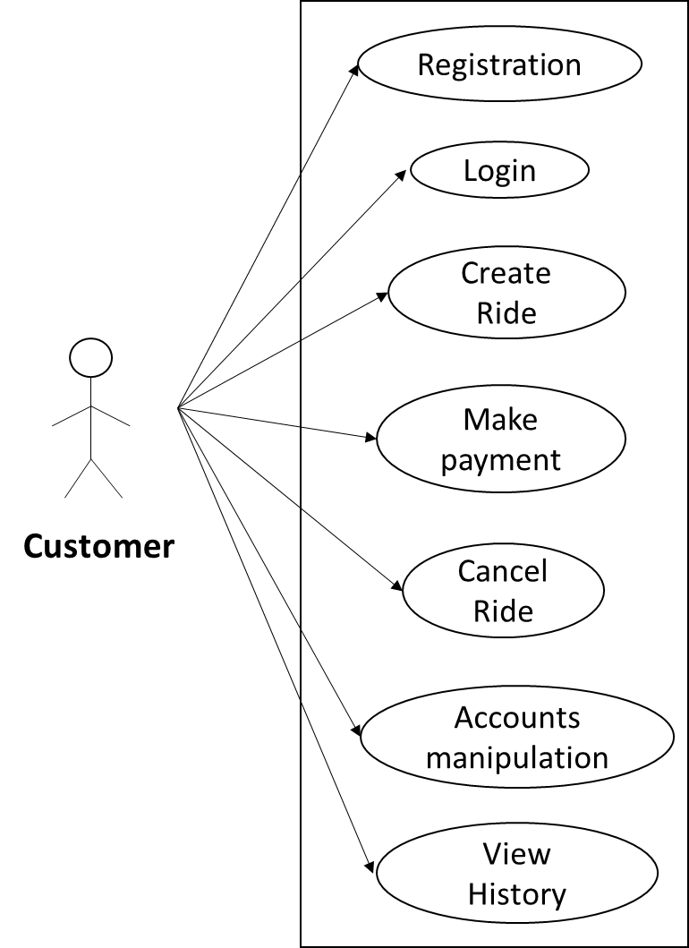

*Fig. Use case diagram for Customer*

1. In Customer use case diagram Customer is the Actor.
2. Customer can handle following use cases:
3. Registration
4. Login
5. Create Ride
6. Make payment
7. Cancel Ride
8. Accounts manipulation
9. View History

**2.5.2 Driver:**

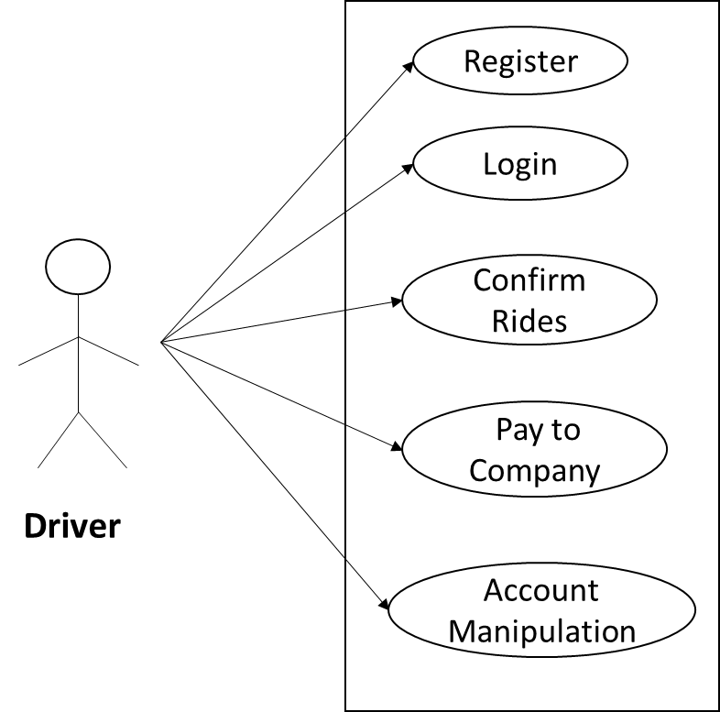

*Fig. Use case diagram for Driver*

1. In Driver use case diagram Wholesaler is the Actor**.**
2. Driver can handle following use cases:
3. Register
4. Login
5. Confirm Rides
6. Pay to Company
7. Account Manipulation

**2.5.3 Admin:**

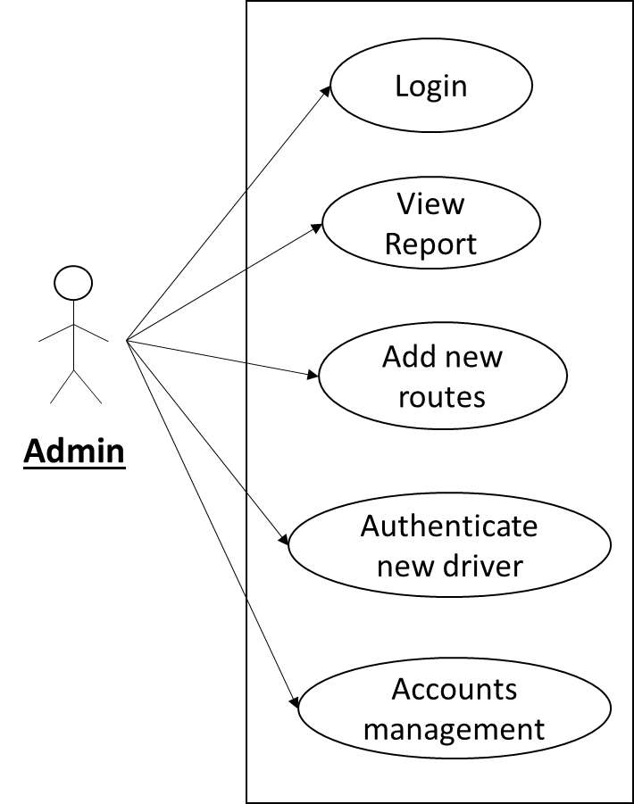

*Fig. Use case diagram for admin*

1. In Admin use case diagram Admin is the Actor.
2. Admin can handle following use cases:
3. Login
4. View Report
5. Add new routes
6. Authenticate new driver
7. Accounts management